1] People send messages to others for different purposes.' Mention at least five purposes / reasons for which messages are generally sent
Ans: (1) To inform someone something,
(2) To greet s some one on special days
(3) To deliver the breaking news.
(4) To express feelings.
2] Drafting a virtual message
Following is a conversation f between Rajas and Ms. Vidya. Ms Vidya had to leave for her office where she works, so she wrote a message for her husband. Draft a virtual message in not more than 50 words.
Rajas: Hello, may I speak to Dr. Tushar?
Ms. Vidya: He has gone to the hospital to attend the OPD. May I know who is speaking?
Rajas: Yes, I am Rajas Yadav. My wife has been having stomach ache since yesterday night. From today morning she has fever too. I would be thankful' to you if the doctor would come to our place to examine her.
Ms. Vidya: Of course, he will come. Please, let me note down your address
Rajas: It is B-101. Vidyut Apartment JVPD, Vile Parle West.
Ms. Vidya: I will give him your message as soon as he returns.
Rajas: Thank you.
Draft message which Rahul's wife has left for him.

Ans:-
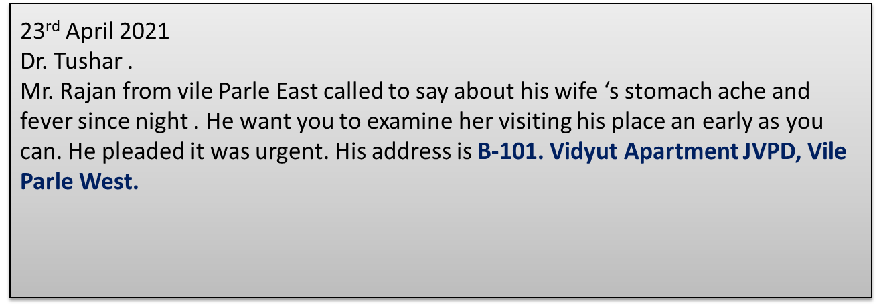
3] Drafting a virtual message
Rahul comes home from office and notices the door of his flat/house is locked. As he had another key with him, he opens the door and enters the house. On table he finds a note left for him by his wife saying that she had to rush to the school of her son who has met with an accident. She also has written if any emergency is there, she will inform him immediately She has also told him to take his evening snacks and he could heat it in microwave if he wants it hot and has asked him to be very careful while handling microwave switch. '
Draft message which Rahul's wife has left for him.
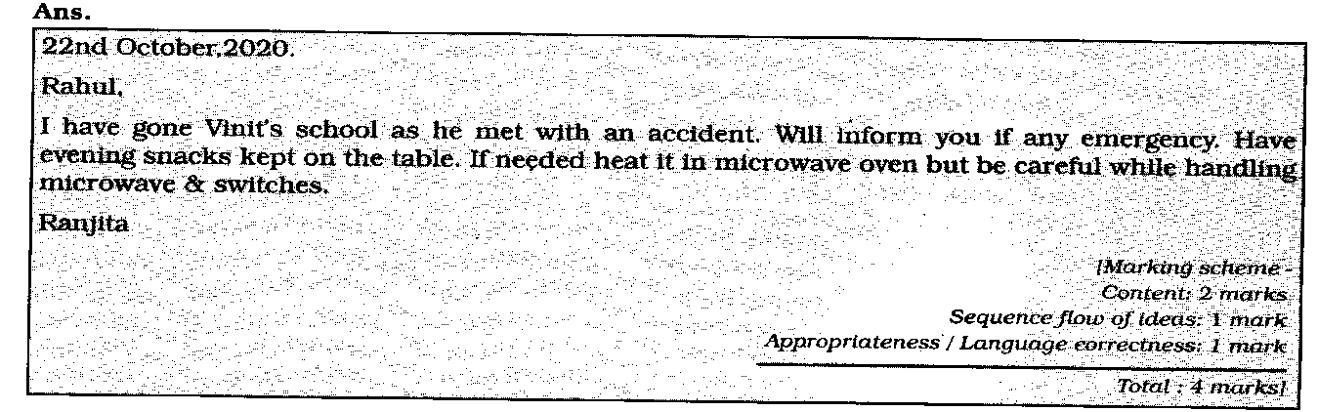

4] Virtual Message:
You are Dipika, a personal assistant to Ms. Priyanka. She was away attending a meeting when Mr. George rang up. You spoke to him and jotted down his message in your note-pad.
Draft a message for Ms. Priyanka using the information using the information in your notes given below.'
Mr. George - rang up - 5 pm - has received the manuscript and CD’s - coming tomorrow to thank Ms. Priyanka personally - to handover the cheque.
Ans:-
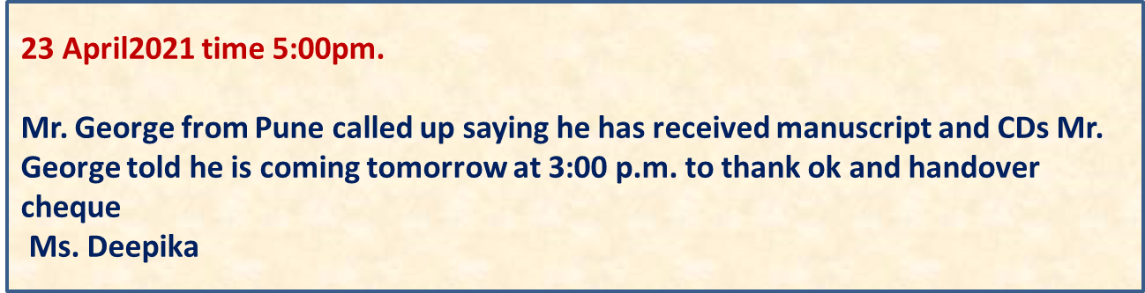
5] Virtual Message:
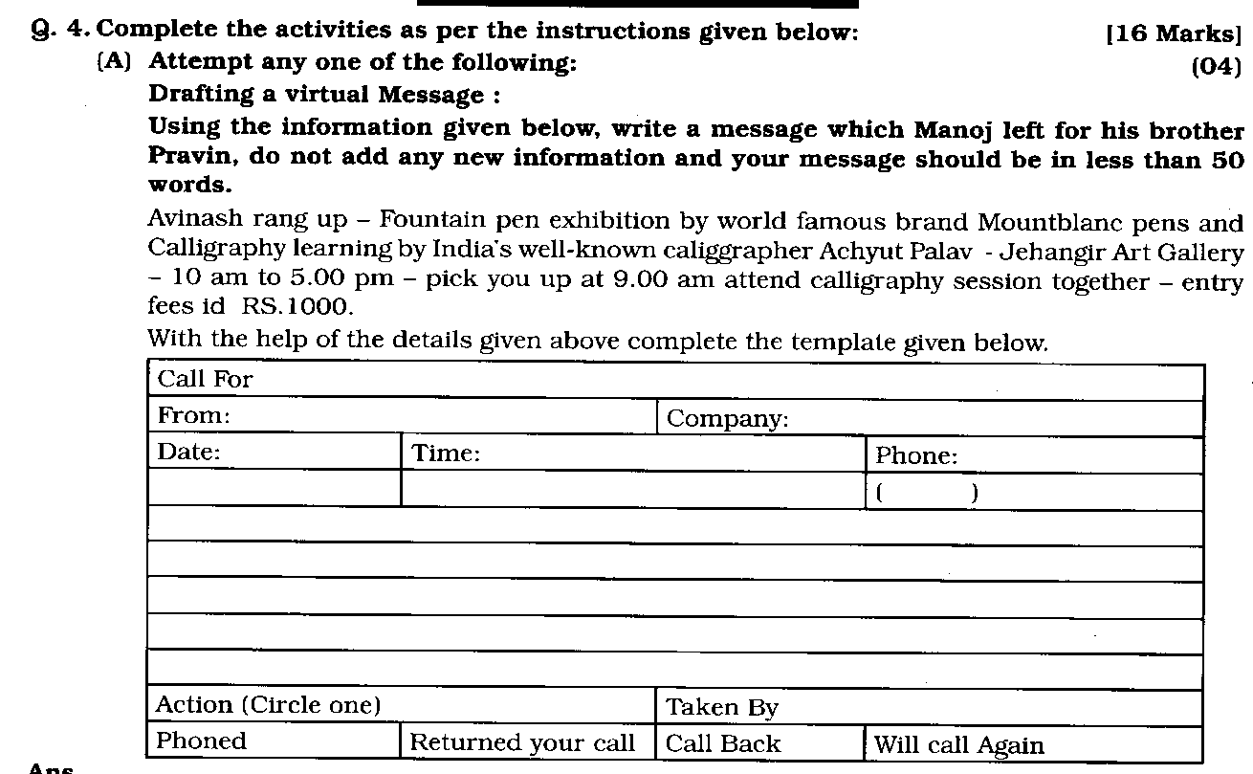
Q
Ans:-
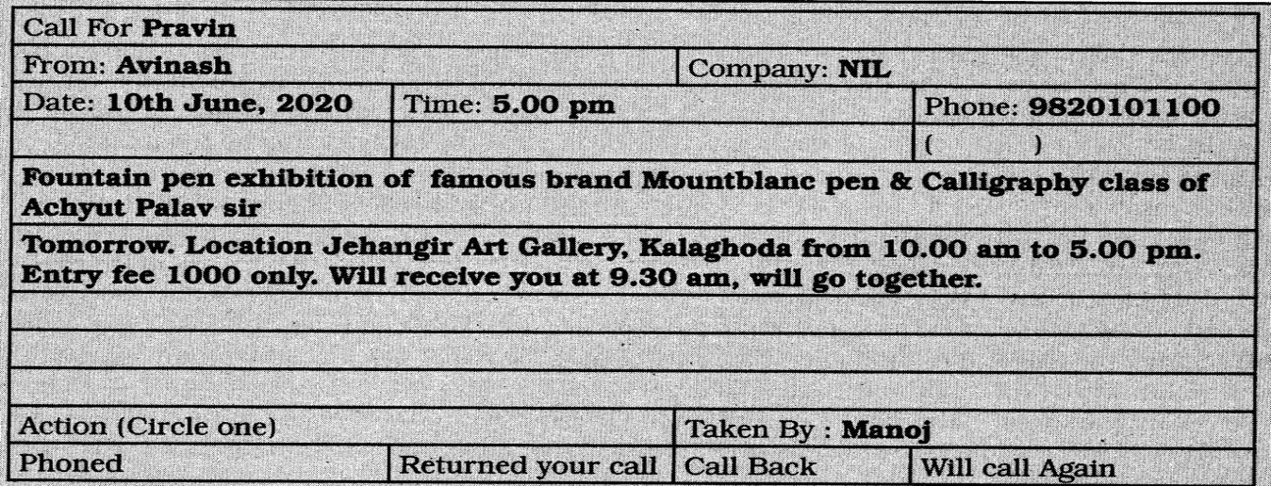

6] Virtual Message:
Read the following conversation between Ms.Aasha and Ashish
Ms. Aasha: Hello, may I speak to Adhir, Please?
Ashish: Adhir is getting ready for his office, May I know who is speaking?
Ms. Aasha: My name is Aasha. I am Adhir’s colleague from his office.
Ashish: Hello. Aasha. I am Adhir’s mother, is there a any message for him to be given? .
Ms.“ Aasha: Yes, please ask him to bring yesterday’s confidential Reports of Employee file to the office today. Yesterday, it was given to him. Our boss would like to see it today before tomorrow’s final audit and inspection.
Ashish: I will definitely inform him. Since Ms. Asha had to go for her morning walk she left a message for Adhir. Draft that message in 50 words.
Ans:-
23rd April 2021 Time 7:40
Dear Adhir your colleague called up half an hour ago and requested you to bring employees confidential report file as your boss is going to verify it before the auditor's inspection
Ms. Asha[ mother]

7] Virtual Message:
Using the information given below, Write a message which Mohit left for his brother Mohan. Do not add any new information, the message should not exceed more than 50 words.
Rajan called up- self written story reading competition- occasion National Book Day and A.P. J. Abdul Kalam birthday- venue is city Library at Church gate. He will pick him up at 5.00
Ans:-
23rd April 2021 Time 7:40
Rajan called up to inform there is a self written story reading competition at City library at Churchgate at 5:00 p.m. onward to celebrate the national reading day as a part of of APJ Abdul Kalam sir's birthday. Don't forget to receive me up by 4 p.m. as we will attend the competition together Mohit

8] Drafting a Virtual Message:
Read the following telephonic conversation between Atharva and Sarika and draft a virtual message based on it. Your message should not be more than 50 words.
Atharva: Hello, may, I speak to Vasundhara?
Sarika: Extremely sorry Vasundhara has still not reached home. May I know who is speaking?
Atharva: I am Atharva, her badminton coach from Pulela Badminton Academy. Wlll you take a message for her?
Sarika: why not sir, please say what the message is?
Atharva: Please inform her that the academy will remain closed for the period nf 8 days as two Corona Positive cases are found toady here In the academy The academy will reopen from 8th of November, 2020.
Sarika: No ,problem sir, I will inform her about lt. As Sarika had to leave for her swimming class. she wrote down a message on her and left it on the table.
Draft that message without adding any new information.

Ans :-
23rd April2021time 5:30pm.
Vasundhara
Atharva sir your badminton coach from Pulela Badminton Academy called he has informed that the duck Academy will remain closed for a day due to Corona positive cases in Academy now the Academy will reopen from
8 November 2021.
Sarika

9] Drafting a Virtual Message:
In pairs, enact the given conversation between Rakesh and Mrs Sarkar.
Rakesh : Hello, may I speak to Dr. Sarkar?
Mrs. Sarkar : He has gone to the hospital to attend the OPD. May I know who is speaking?
Rakesh :Yes, I am Rakesh Sood. My wife has been having a severe headache since yesterday. Since this morning she has also developed a high temperature. I would be very grateful if the doctor could come over to our place to examine her.
Mrs. Sarkar : of course. Please let me note down your address.
Rakesh : It is B-49, New Colony.
Mrs. Sarkar :I will give him your message as soon as he returns.
Rakesh : Thank you.
Mrs. Sarkar had to leave for the school where she teaches. So she wrote a message for her husband.

Draft the message to Sumit, her husband, in not more than 50 words. (Students can enact the conversation in class.)
Ans
23rd April2021time 5:30pm.
Sumit
One Rakesh Sood staying at B-49, New Colony rang up this morning to say his Wife has not been keeping Well. She had headache yesterday and has been running a high temperature since this morning. He Wanted you to go over their place and attend her at the earliest.
Sunita

10] Drafting a Virtual Message:
Using information from the dialogue given below, write the message which Amrita left for her brother, Sourajit. (Do not leave out any vital information or add any new information).
Shekhar : Is this 28473892?
Amrita : Yes, May I know who is speaking?
Shekhar :I am Shekhar, I Want to speak to Sourajit. I am his friend from IHM, Goa.
Amrita : I am his sister. Souraj it is not at home at the moment. Can you ring up a little later?
Shekhar : I shall be a little busy. Actually, I have got a placement at the Hotel Mumbai, and will have to join with immediate effect. So right now I am trying to get all the formalities completed. This is the news that I wanted to give Souraj it. Will you do that for me? Also tell him that I will let him know my new cell phone number as soon as I get one. .
Amrita : I’ll do that. Bye and all the best.
Amrita had to leave for office. So she wrote. a note for Sourajit. Draft her message in not more than 50 words
Ans:-
30th Sept, 8:30 am
Sourajit
Your friend Shekhar called up to say that he had got a placement in Hotel Mumbai. He is at present busy getting all the formalities done. He said he
would give you his new cell number as soon as he got it.
Amrita

11] Drafting a Virtual Message:

You are Priyanka, a personal assistant to Ms Sen. She was away attending a meeting when Mr. Garg rang up. You spoke to him and jotted down his message in your notepad.
Ans:
14/10 : 6:20 am
Ranajit
Aashna called up right now. She wanted you take along your biology notebook to school today. She told that she would like to see the notes given by your biology teacher during absence yesterday.
Dad

12] Drafting a Virtual Message:
Rajat comes home from school and finds the door locked. Since he has a duplicate key he enters and finds a note from his mother kept on the table. In it she explains that she had to rush to the hospital with Mrs Manohar, their eighbor, who had met with an accident. She has also written that
he should have the rice and curry kept on the dining table for lunch. He could heat the food the microwave oven if he wanted to, but he should be very careful while handling the switch.
Draft the message which Rajat’s mother left for him.

Ans:-
23April 2021 - 11:30 am
Rajat Mrs. Manohar has met with an accident. I am rushing to hospital with her. I have kept rice and curry on the dining table for your lunch. Heat it in the microwave if you Want to - be careful While handling the switch.
Mom

13] Drafting a Virtual Message:
Using the information given below, write a message which Manu left for his sister, Renu. (Do not add any new information. The message should not exceed 50 words). Ruhaan rang up - book-reading session ‘Children Ask Kalam’ – Dr. A.P.J. Abdul Kalam - competition of letters received by him from children and his answers – Oxford Book Store - 8 pm, this evening, - pick you up - 6:30pm - attend reading session together.
Ans
8th Nov. : 2 pm
Renu
Ruhaan rang up to say that there is a book-reading session at Oxford Book Store this evening at 8 o’c1ock. The book is “Children Ask Kalam” – a compilation of letters received by Dr. Kalam and his answers. I will pick you up at 6:30 pm sharp. We will attend it together.
Manu

14] Drafting a Virtual Message:
Given below is a template for a message. Imagine you are working as a receptionist in a company and you are supposed to maintain the call record. Complete the details given in the template for a particular message.

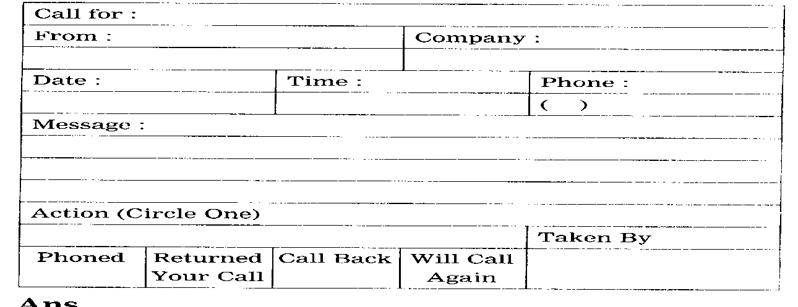

Ans

